1. To retrieve the firebase data by using pycharm, google cloud has document that how to write a queries(it is similar to SQL but we are writing in python)
2. Before going to write a query first you understand

* What is FOLKGuides collection?
* What data it is storing?
* Which attribute should I kept in condition, then I can get data

1. Below is the link for firebase queries in python, please go through that and understand and practice multiple times in pycharm(practice practically in pycharm then only you can understand)

<https://firebase.google.com/docs/firestore/query-data/queries>

1. And see the structure of firebase, below is the screen shot for your reference

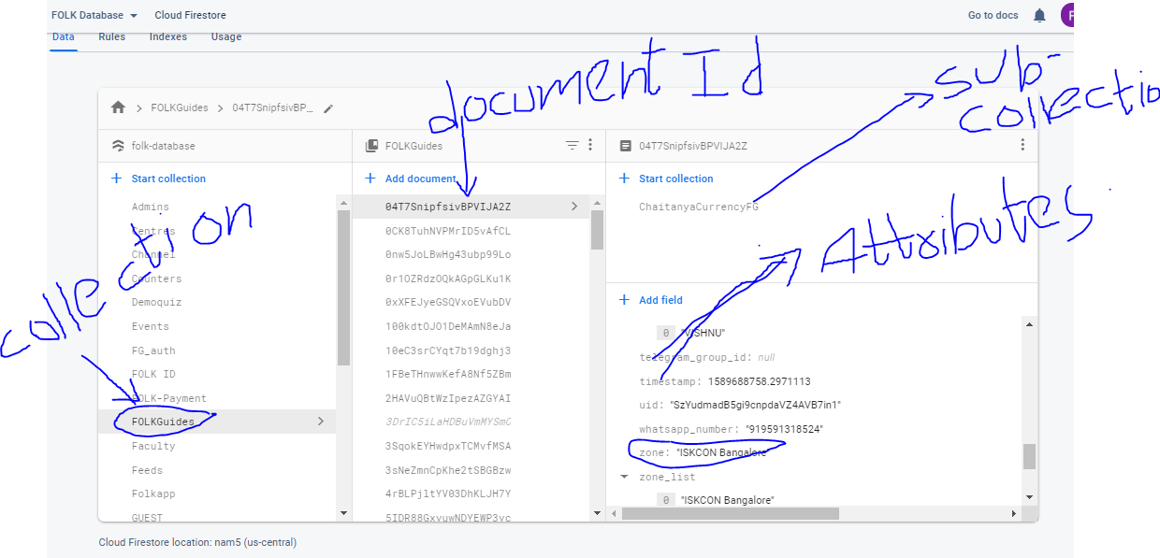

* In the above screenshot I am mentioned what is collection(means table name)
* And what is document id(means a row in a table)
* What is attributes(data storing in a row)
* What is subcollection( in a document we can create one more table is called as subcollection)

1. Now the question is “Write a query to retrieve the “FOLKGuides” data where “zone” is equal to “ISKCON Bangalore” by using pycharm?”
2. If you go through the link and if you have little knowledge of SQL then it is sufficient, below iam writing a query but before going to see that please try to write on your own
3. Docs = db.collection(‘FOLKGuides’).where(‘zone’,u’==’,’ISKCON Bangalore’).stream()

For doc in docs:

Print(doc.to_dict())

1. The explaination for above code is

Iam taking the data from “FOLKGuides” where “zone” is equal to “ISKCON Bangalore”

* The reason iam kepting the stream() it get all the data of folkguides which satisfy that condition
* Firebase stores the data in JSON Format, lets say when iam executed above query we get 100 documents(rows) , all that data in stored in docs but we can not print because it is in JSON format
* That is the reason iam writing the for loop , going the one by one docs and converting into dictionary format and printing
* Note: we can not print data directly we should convert to some format(dictionary) and print